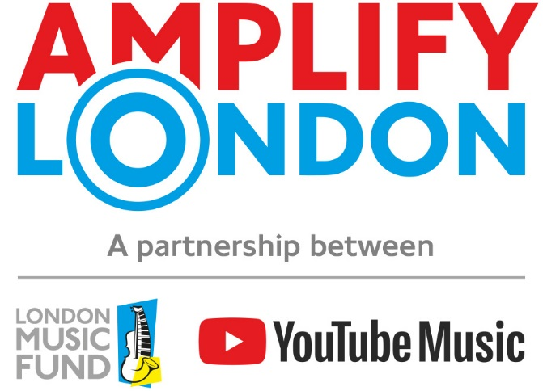

We are looking for grassroots organisations providing training opportunities and industry pathways for young people primarily aged between 14-21 (but can include participants up to the age of 25) in music, music production or music technology. Do you know an organisation that could benefit from our funding?

Amplify London is a pioneering programme set up by the London Music Fund in partnership with YouTube Music in February 2020. Applications are now open for 2024 project funding.

Over the last three years, 15 organisations have been supported by Amplify London to deliver a project for young people. We are looking for organisations and projects providing musical training or development opportunities (for example music creation, production, technology, recording, creative career support, and live or digital performance opportunities) for young Londoners primarily aged 14-21 (but can include participants up to the age of 25) who face barriers in their music-making. The fund aims to help each organisation develop their work and forge links with the music industry and the music education sector, working in collaboration with London music education charity Sound Connections, with the ultimate aim of supporting young people into the music industry.

The London Music Fund is an independent charity (no. 1141216) with the Mayor of London as Patron. We have more than 12 years’ experience of funding successful music education projects and have awarded over £4m in funding towards music education in London since 2011.

This ground-breaking new programme is supported by YouTube Music, enabling access to mentors and artists, offering networking opportunities and fantastic exposure for small projects and organisations. It is a new fund just for London, aiming to provide small arts and/or youth organisations get to the next level in their delivery, working with Sound Connections to offer exemplary administration and monitoring support including online surgeries and hands on support with evaluation.

To be eligible to apply for 2024 project funding:
- The applicant must be an organisation, not an individual.
- The organisation must:
  - Be a UK based organisation with a signed governing document.
  - Have been legally constituted and providing activity for one year and have a set of accounts.
  - Have the relevant insurances* in place (including employers’ and public liability) and must be compliant with all relevant statutory legislation.
  - Have a safeguarding policy* that is regularly reflected on and updated.
  - Have an annual turnover of no more than £500,000. Organisations with lower turnovers will be prioritised.
  - Not be a music service / hub or school, or an Arts Council funded ‘national portfolio organisation’.
  - Be regularly providing music and/or music technology activity/projects for young people primarily aged 14-21.
  - Attend an Amplify London application surgery
- The proposed project must:
  - Take place within the local community.
  - Involve at least 10 young people aged between 14-21 (but can include participants up to the age of 25).
  - Take place between January 2024 – December 2024 (the project can last for any length of time within this period).
  - Provide talented young songwriters/artists/producers/engineers with training and skills and empower them to access a career in the music industry.
  - Work with young people who have already demonstrated an interest in or talent for their chosen pathway.

*We don’t automatically request policies, but they should be available on request.

We are now accepting applications for 2024 projects.
The deadline for submitting an application is 5pm Friday 17th November 2023

Please visit our website for more information, FAQs and deadlines, or email AmplifyLDN@londonmusicfund.org

